USER GUIDE

CLASSIM

Crop, Land and Soil SIMulation

Current version 2.2

# Foreword

In some ways, the science of crop and soil modeling has not changed very much over the past decades. Models still attempt to quantify certain components of the soil-plant-atmospheric continuum into equations, mathematics, and quantitative relationships that are effectively transformed into lengthy snippets of programming source code to simulate, study, and learn about the relationship of crop growth and development to genetic, environment, and management inputs. At the USDA-ARS Adaptive Cropping Systems Laboratory in Beltsville, Maryland, our core philosophy regarding crop modeling recognizes the constant need to continually incorporate new science and methodologies into crop and soil models. This is particularly important as agricultural systems are facing increasing pressures from climate change, extreme weather events, resource and water scarcity, and suitable land availability from multiple economic and societal sectors. New components, such as coupled photosynthetic and transpiration processes enveloped within an energy balance at the leaf level, along with two-dimensional soil descriptions and associated root, water, heat, and gas movement processes represent what we believe are more accurate methods to simulate such challenges. But more science frequently increases the complexity in using and operating crop models for the end-user. Recognizing this issue, the new Crop, Land And Soil Simulation (CLASSIM) interface was developed to simplify such tasks for current (and soon to be integrated) USDA crop models for Corn (MAIZSIM), Cotton (GOSSYIM), Potato (SPUDSIM), Rice (RICESIM), and Soybean (GLYCIM).

As of September 2022, this current version of CLASSIM is integrated with MAIZSIM, GLYCIM, GOSSYM and SPUDSIM models.

Contents

Foreword 2

Introduction 4

Installation 5

CLASSIM Layout 6

‘Welcome’ Tab 7

‘SITE’ Tab 8

‘SOIL’ Tab 10

‘WEATHER’ Tab 12

‘CULTIVAR’ Tab 13

‘MANAGEMENT’ Tab 14

‘SEASONAL RUN’ Tab 17

‘ROTATION BUILDER’ Tab 19

‘SEASONAL OUTPUT’ Tab 21

‘ROTATION OUTPUT’ Tab 26

SAMPLE – Input Data 33

APPENDIX A – Weather Data 34

APPENDIX B – Cultivar Variables and Units per Crop 36

APPENDIX C – Output Variables and Units 39

APPENDIX D – Technical Odds and Ends 42

APPENDIX E – CLASSIM Data File Storage 43

APPENDIX F – KNOWN MODEL BUGS 44

USER EXPERIENCE 45

# Introduction

The CLASSIM interface was developed in PYTHON and designed to work as a standalone Windows based application. This graphical user interface (GUI) integrates with an SQLite database to store model input data and output results using SQL commands. CLASSIM simplifies the user tasks associated with developing input files for USDA-ARS crop models as well as visualizing results from above ground plant processes and two-dimensional soil responses.

The current version allows for extraction of available soil data from the NRCS SSURGO database based on latitude and longitude. CLASSIM also incorporates an API developed by the University of Georgia to extract up to five years (from the current date) of hourly weather data using the North American Land Data Assimilation System (NLDAS, [NLDAS: Project Goals | LDAS (nasa.gov)](https://ldas.gsfc.nasa.gov/nldas/)) as the data source for air temperature, relative humidity, wind speed, and solar radiation. The Multi-Radar Multi-Sensor (MRMS) project dataset ([NSSL Projects: Multi-Radar/Multi-Sensor System (MRMS) (noaa.gov)](https://mrms.nssl.noaa.gov/)) is used for daily rainfall estimates.

CLASSIM defines a ‘Site’ as the geographic location at which a particular model rotation, or execution, is to be run. Within a ‘Site’, the user then creates, or selects if already existing, ‘Soil’ and ‘Weather’ data. ‘Weather’ data is also associated with a ‘Weather Station’ that contains basic climatic information at each Site including typical rainfall intensity, windspeed, CO2 concentration, and nitrogen amount within rain (if any) that is associated with that location. A ‘Site’ can have multiple ‘Weather Stations’, and each ‘Weather Station’, can have multiple years of ‘Weather’ data associated with it.

Experimental data, or ‘Management’ information describes the crop, cultivar, field practices, and simulation controls associated with a particular experiment. While not directly under the umbrella of a ‘Site’ or ‘Weather Station’, the user should take care that weather is available for the year referenced in the experimental data.

A model rotation is then assembled with the user selected incorporation of a ‘Site’, ‘Soil’, ‘Weather Station’, ‘Weather’ file, and a ‘Management’ file. Various output options are available to the user including summary output, time-series plots, and 2D soil profile information including nitrogen, water and root length density. The next sections in this manual describe the input process and the various data entry needs and approaches.

# Installation

Users can install using an automatic installation executable or a manual installation. Both methods have been tested on Windows 10 personal computers.

(1) For the automatic executable installation, copy the ‘setupCLASSIM.exe’ file to your local PC and double click to install. Select for desktop icon to launch the program.

(2) For manual installation or updates:

Overview

At the completion of installation, Users will have two new folders on their hard drive:

C:\Users\User.Name\Documents\CLASSIM

C:\program files\CLASSIM

The ‘CLASSIM’ subfolder must be contained within the Documents folder. Within this folder include subfolders for input and output files for all model runs, crop and soil model executables, and associated databases.

The ‘CLASSIM’ subfolder is installed under the program files folder with other 64 bit programs. This is where the python libraries and CLASSIM executable are stored.

Once installed, the User can execute the CLASSIM program by opening and command prompt (type “cmd” in the Windows Search Bar (a link to the desktop can also be created). The advantage of running from a command prompt is that – if there is an error launching CLASSIM, the command window won’t close immediately and one can copy the error to report to us:

-change directory to the CLASSIM installation folder (cd C:\Program files\CLASSIM)

-run classim.exe from command line

-after about a minute, the interface will start up.

The main CLASSIM folder will also include model executables and extensions (2dglycim.exe, 2dgossym.exe, 2dmaizsim.exe, 2dspudsim.exe, createSoilFiles.exe, Rosetta.exe, soil.exe, GasExchanger.dll, GLYCIM.dll, GLYCIM_GasEx.dll, GOSSYM.dll, GOSSYM_GasEx.dll, GridGenDLL.dll, lightenv.dll, maizsim.dll, spudsim2-1.dll) and databases (crop.db, cropOutput.db)

# CLASSIM Layout

CLASSIM (Fig. 1) was designed to provide the user with simplified access for methods to input data, assemble and execute model simulation runs, or view the output data. A series of ten ‘Tabs’ that run along the top of the CLASSIM window are accessible to the user (Figure 1). Selecting a Tab will open a new window in the interface related to the task associated with the given Tab. For example, ‘Site’, ‘Soil’, ‘Weather’, ‘Cultivar’, and ‘Management’ Tabs are associated with model input data. The user can either provide new input data related to the Tab description or look at existing data that was previously entered into the database. The ‘Seasonal Run’ and ‘Rotation Builder’ Tabs are where the user assembles the input files used to execute a model run for a given scenario or rotation. There are also options on this Tab for the user to conduct sensitivity analyses with the assembled model run. The ‘Seasonal Output’ and ‘Rotation Output’ Tabs provide a text summary of the results from a given model run or rotation as well as multiple graphical outputs for visualization purposes.

Upon launching the interface, the ‘Welcome’ Tab starts by default. You may need to resize the screen as needed. Tabs along the top of CLASSIM are not in any order. That is, the user can select whatever Tab is needed to accomplish their goal.

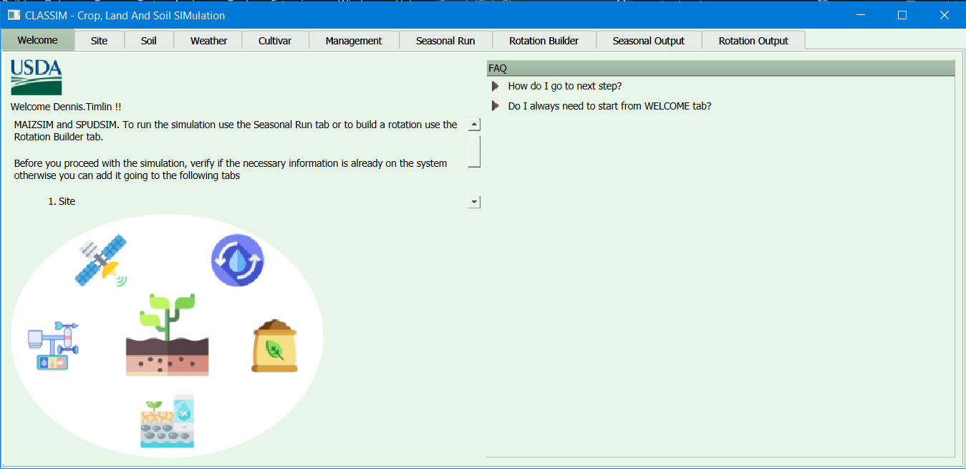

Figure 1: CLASSIM welcome screen showing multiple Tabs that the user can select on the top of the screen (Welcome, Site, Soil, Weather, Cultivar, Management, Rotation Builder, Seasonal Output and Rotation Output).

# ‘Welcome’ Tab

The ‘Welcome’ Tab is the default Tab selected when CLASSIM is first launched (Fig. 2). Information on this Tab screen provides stream-lined FAQs (frequently asked questions) associated with using the interface. First time users likely need to progress in order of the Tabs (from left to right) to enter their data into the database using CLASSIM.

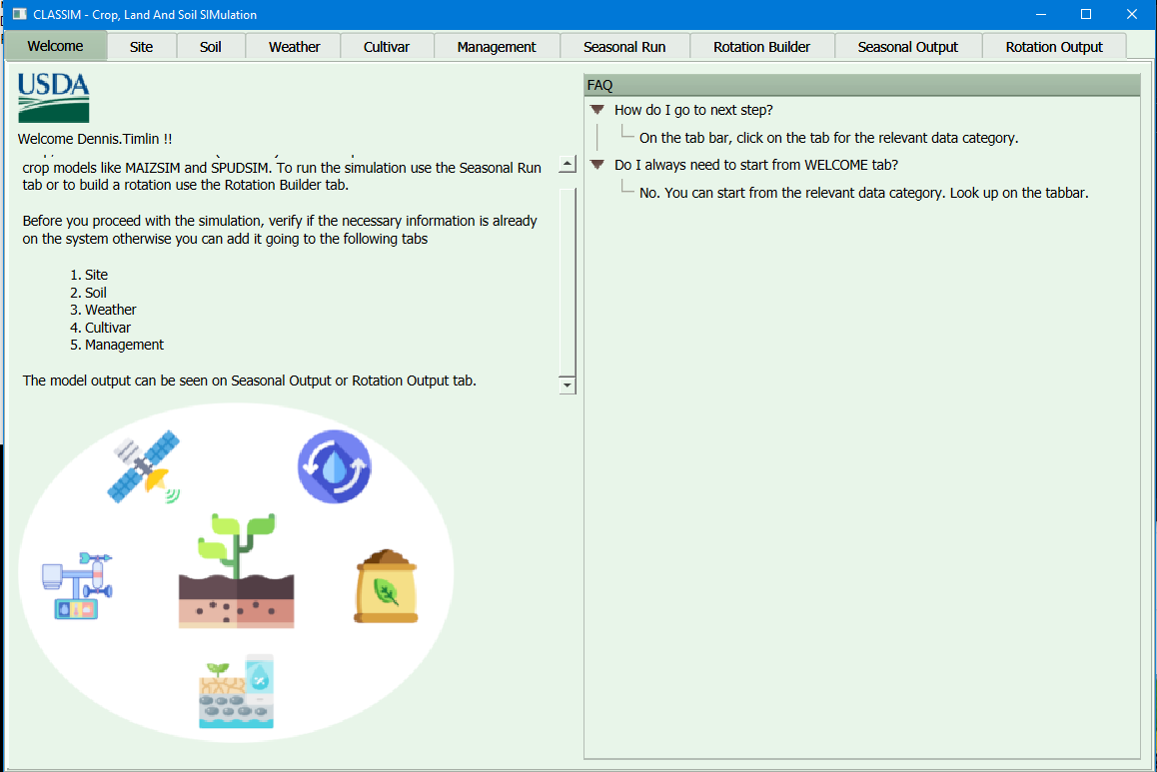

Figure 2: Welcome Tab. This is the default Tab selected when CLASSIM is first launched.

# ‘SITE’ Tab

The ‘Site’ Tab is where basic information regarding the geographic site at which a given model simulation is to be run or executed (Fig. 3). User can verify if their desired site currently exists in the database by clicking on the site drop down list (Fig. 4) or can enter their site by clicking ‘Add New Site’ from the box.

Figure 3: Site tab with CarlowIre site selected.

Figure 4: Site tab with drop down box accessed. User has selected 'Add New Site' in the box.

An existing site can be selected and modified if necessary (Fig. 5). Required information includes latitude, longitude, and site elevation or altitude (meters). User must give the new or modified site a name and select the ‘Update’ button to save in the database. This new site will be now available for use when adding new soil, weather data, and assembling the model execution run in the ‘Seasonal Run’ and ‘Rotation Builder’ Tabs. Remember to save any changes before leaving this Tab!

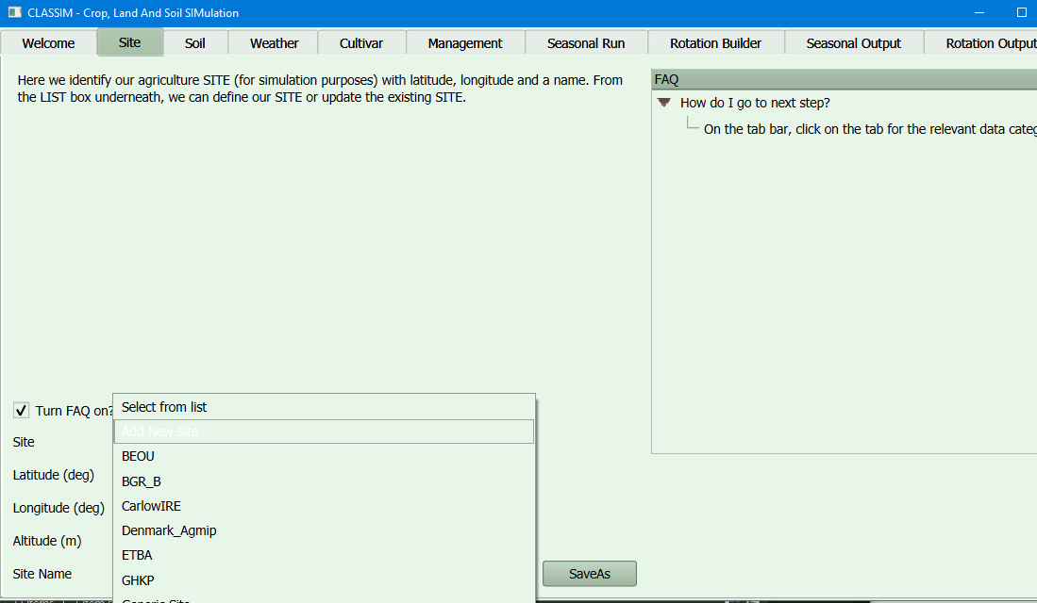

Figure 5: The user in the process of entering information for a new site called CLASSIM.:

# ‘SOIL’ Tab

The ‘Soil’ Tab presents multiple options for the user to enter soil data. As with the ‘Site’ Tab, the user first selects from the dropdown list either an existing soil or a new soil to be added to the database. The example shown in Fig. 6 shows a table for an existing soil that was pre-entered, Beltsville1. One can see the Site was called “belts”, and then the soil properties are provided for three layers. Soil data must be input for each available soil layer or horizon, with each layer represented as a row in the Table. The FAQs provide information on each of the soil input information. Note that a ‘-1’ means the information is missing, and the user is asking CLASSIM to estimate the missing values. One caveat, however, is that only the hydraulic properties (TH1500, and other columns to the right) can be estimated with CLASSIM. Values for OM, NO3, NH4, HNew and Tmpr need to be provided by the user! Don’t forget to name the Soil and click on ‘Update’ To save!

Figure 6: Soil example with an existing Soil called 'Beltsville1'.

When a User needs to enter a new soil, click on the Soil List dropdown box, and select the ‘Add New Soil’ option. The user will need to select an existing Site first. CLASSIM will automatically pull data from the NRCS SSURGO database, if available, and then the user can edit the necessary fields. Note that the user can highlight a row by left clicking on the number, and then right clicking on the same number to add or remove rows (Fig. 7). This can be useful, for example if a new layer needs to be added:

Figure 7: Layer three was highlighted in this example. By right-clicking on the '3', the User can add, delete, or remove a new soil layer if needed.

# ‘WEATHER’ Tab

Weather information in CLASSIM consists of two parts. The first is to select, or create, a Station, and the second is to upload, or download, actual weather data. In the example below, we selected an existing Station called ‘IowaH’. This Station is associated with a particular ‘Site’ which is ‘Iowa’ (Fig. 8). There are four characteristics that describe any weather file associated with the Station. These are the average wind speed, rainfall rate (or intensity), average CO2 concentration, and the content of nitrogen in the rainfall. Again, more information for each variable can be found in the FAQs. Creating a new Station follows a similar procedure as with ‘Site’ and ‘Soil’ Tabs.

*Figure 8: Weather example with a Station called ’IowaH’.*

The User can then either upload (click “upload file”) an existing weather file which must be in *.csv format or can download (click “download file”) hourly weather data automatically from an internal API that pools the last 5 years of data from NLDAS and MRMS databases (NASA and NOAA administrations respectively). If you are uploading a weather file and you don’t want the data to have the same station name, you should provide a column named weather_id on the .csv file with the identifier you want to have. Note that downloading can take two to five minutes during which CLASSIM will appear to be inactive. A message will indicate on the screen if the download was successful. As in the Figure 8, there is an availability report for the downloaded data on the bottom left of the screen if the download was successful. Note that the download option will only provide data up to five years prior to the current date. If a User is interested in older data, they must upload their information separately.

As always, make sure to “Update” your changes or they will not be saved to the database.

**Further information on weather data requirements and example files are given in the appendix.**

# ‘CULTIVAR’ Tab

Cultivar information for our crop models is described as so-called ‘genetic’ variables. The process of model calibration ‘should’ refer to adjusting the values of these variables to match that of the phenotypic responses of a given variety (i.e. adjust values such that differences between observed and simulated results are minimized). The current version of CLASSIM is populated with coefficient values for several varieties of cotton, maize, potato and soybean. Fig. 9 show an example for Potato variety called ‘Harley Blackwell’. As with other Tabs, the dropdown boxes can be used to select user options. In this case, they are crop type and cultivar list. User can enter in a new variety, delete an existing variety, or modify the current values.

**CLASSIM currently does not have a methodology for estimating these values.**

Figure 9: Cultivar example with a potato variety called ’Haley Blackwell’.

# ‘MANAGEMENT’ Tab

Management tab is where the user enters information regarding a particular experiment or field location in which they wish to conduct a simulation. CLASSIM has this organized by the following hierarchy, crop → experiments → treatments → operations. Experiments are organized by crop type (cotton, fallow, maize, potato, or soybean for now). An experiment can have multiple treatments, each of which could be viewed as a different field plot, treatment, or even statistical block with a given experiment. Treatments in an experiment do not necessarily have to be associated with the same geographical location, but it may make things easier for the User to keep it organized in this way. Each treatment will have multiple operations, including farm management and simulation information. Examples are provided below.

If you click on Open Management Report, a new window will open and you can sort the information clicking on a given column name or you can search for a particular information typing on the box under Management Report, if the search is successful, the information will be highlighted, Fig. 10.

Figure 10: Management Report example searching for ‘Beou2009’.

The following figure shows an example of multiple experiments already stored in the CLASSIM database for Cotton, Fallow, Maize, Potato and Soybean. The User can select one of these existing Experiments to read through, add a new treatment, add new operations, or modify / delete these.

1) Example of an existing experiment and treatment:

On Fig. 11, the User has selected the Maize crop, with the BEOU1401 Experiment. There are four treatments within this Experiment. The 1401 treatment was selected, and a treatment summary is shown in the box to the right. Users can see operations including the cultivar, planting density, seed depth, row spacing, planting dates, and other information. The user will see an option to delete this treatment or copy this treatment to a new treatment. The advantage of copying a treatment is that if you want to do a simulation varying an operation of an existing treatment you don’t need to enter all operations again, you just modify what you want to vary.

Figure 11: Management example with treatment 1401 for experiment BEOU1401 for crop corn selected.

Double-clicking the treatment gives access to the operations list for that treatment, to view/edit an operation click on the operation. These include:

Simulation Start

- Calendar dates for initiating a model execution run. Start date should be 10 to 14 days prior to sowing (or emergence) dates to allow soil profile to be initialized. Input for cultivar, plant density, seed depth at planting, row spacing, location of planting grid (choose left by default) and if auto irrigation is desired.

Sowing / Emergence / Harvest Date

-Calendar dates. Sowing date refers to planting date. Emergence date is a required input for potato, but not corn. Harvest date is the date at which the field was harvested. A later date can be specified in case maturity occurs after the harvest.

Simulation End

-Calendar dates for ending a model execution run. End date needs to be either the harvest date or afterwards.

Add New Operation

-Currently this option is used for adding new fertilizer events, surface residue and plant growth regulator chemical (available only for Cotton).

Fertilizer Class

-There are three options for fertilization: Fertilizer-N, Litter and Manure. Enter the calendar date, amount (in kg N ha-1 and/or kg C ha-1) and depth of incorporation for each fertilizer event. A new Fertilizer Class operation must be added for each individual fertilizer event.

Surface Residue

-For Surface Residue the only option is Rye. Enter the calendar date, and amount that can be mass kg ha-1 or thickness in cm. You cannot have a tillage and surface residue at the same time.

Plant Growth Regulator Chemical

-Plant Growth Regulator Chemical operation is only available for Cotton. The options are Def, Dropp, Gramoxon, Harvade, Pix and Prep. You will need to select application type and application units and provide the amount for application bandwidth and application rate.

On Fig. 12, the Simulation Start was selected. Changes can be done directly to the boxes on the right, be sure to click ‘Update’ to save any changes.

Figure 12: Operation Initial Field Values was selected.

To add a new experiment or treatment, double click on the corresponding element, and provide a new name to the right, and then click ‘save’ (Fig. 13):

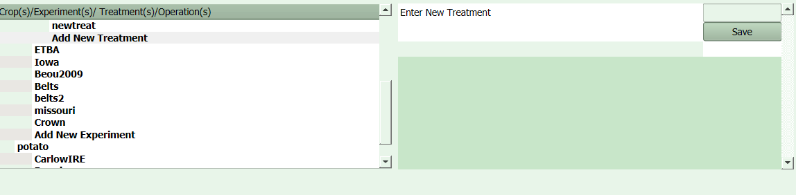Figure 13: Add New Treatment option was selected.

Double click on the new treatment to add operations – values are pre-populated and will need to be changed as desired.

NOTE: When updating operation dates on treatment, it is best to start with ‘Simulation Start’ followed by operations displayed in the sequence, otherwise you might get an error when CLASSIM is doing validation on operation dates, for example, no operation can have a date prior to the simulation start date.

# ‘SEASONAL RUN’ Tab

Seasonal Run is where the user assembles the input data needed to conduct a single model simulation (execution), however the user can execute more than one simulation. To add or delete a simulation select the entire row and right click. It will open a dialog box with instructions. Each simulation is associated with a combination of crop, site, soil, station, weather data and experiment/treatment. The user also has an option to apply climate variance manipulating temperature rain and CO2.

As shown in Fig. 14, the various input data are selected from drop down boxes. Inputs for Soil, Station Type and Weather will be influenced by the Site selection (remember, a Site is required when you create input data for Soil and Weather):

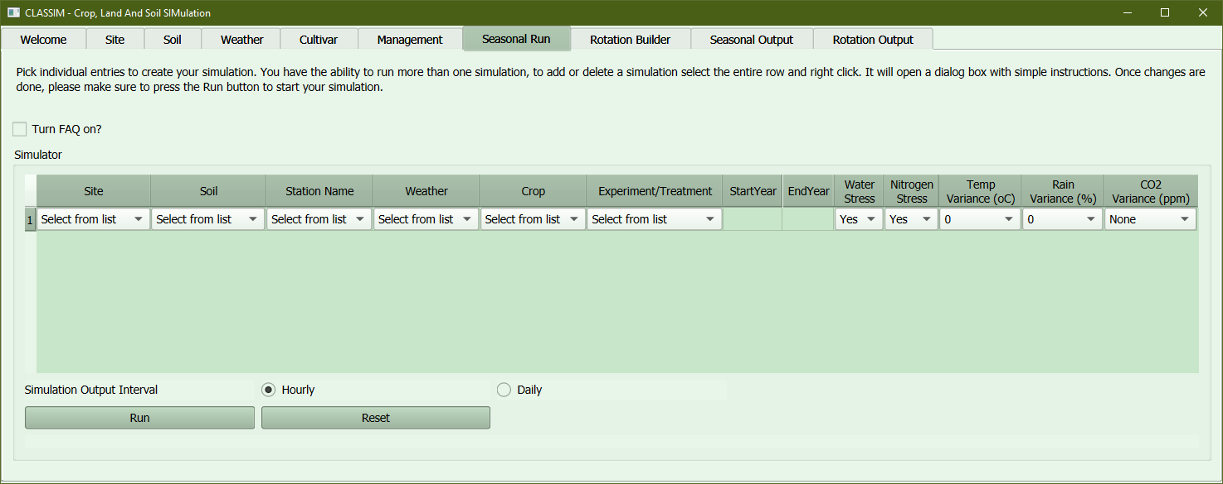

Figure 14: Seasonal Run example.

On Fig. 15, the BEOU site was selected, along with associated Soil, Station, and Weather data. After selecting the crop type (maize in this case), all available experiments and treatment combinations are listed. Start and End Years are automatically selected based on the information associated with those treatments. NOTE: selection of an experiment/treatment combination for which the start/stop dates are outside the weather data range will cause an error during model execution!

*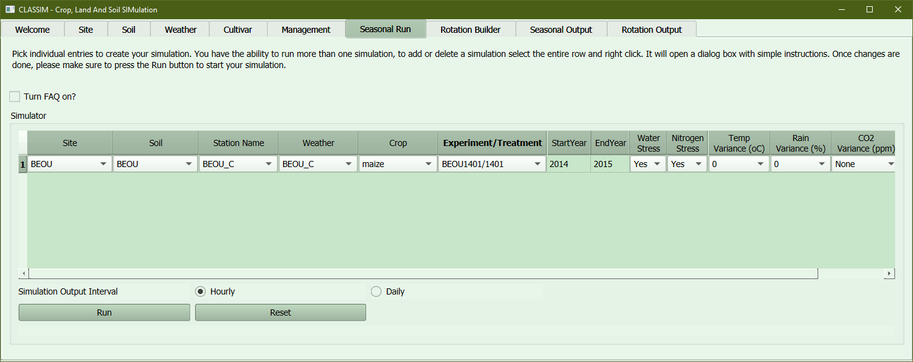Figure 15: This example shows an example for entry to run maize model.*

Currently there are options to study non-limited water and nitrogen conditions (potential yield) in the simulation run, but these only work for potato. User can also apply climate variance that will be applied for the temporal range of the simulation on temperature, rain and CO2.

When ready, the user can click on the ‘Run’ button and select the desired data output interval (Fig. 16). Daily output is considerably faster. The simulation progress will be displayed below the run button, when the simulation is completed, you will see the message “Check your simulation results on Output tab”, please allow up to 4 minutes for hourly output, less than 1 minute for daily. The output is now ready to look at Seasonal Output tab.

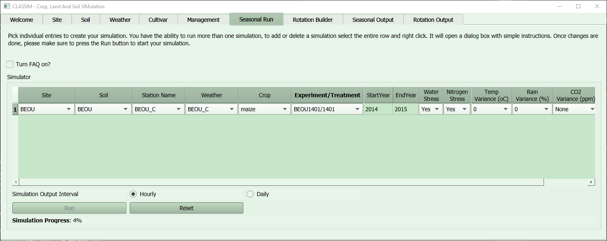

Figure 16: Management example with treatment 1401 for experiment BEOU1401 for crop maize selected

# ‘ROTATION BUILDER’ Tab

Rotation Builder is where the user assembles the input data needed to conduct a sequence of simulations with one or more crop. Simulation will only work if there is weather data available for the duration of all management operations in each crop rotation. To add or delete a rotation select the entire row and right click. It will open a dialog box with instructions. The rotation builder is associated a unique site, soil, station, and weather. The user then selects the combination of crop, experiment/treatment, and has an option to add water and/or nitrogen stress and variance for temperature, rain and CO2 for each rotation.

As shown in Fig. 17, the various input data are selected from drop down boxes. Inputs for Soil, Station Type and Weather will be influenced by the Site selection (remember, a Site is required when you create input data for Soil and Weather):

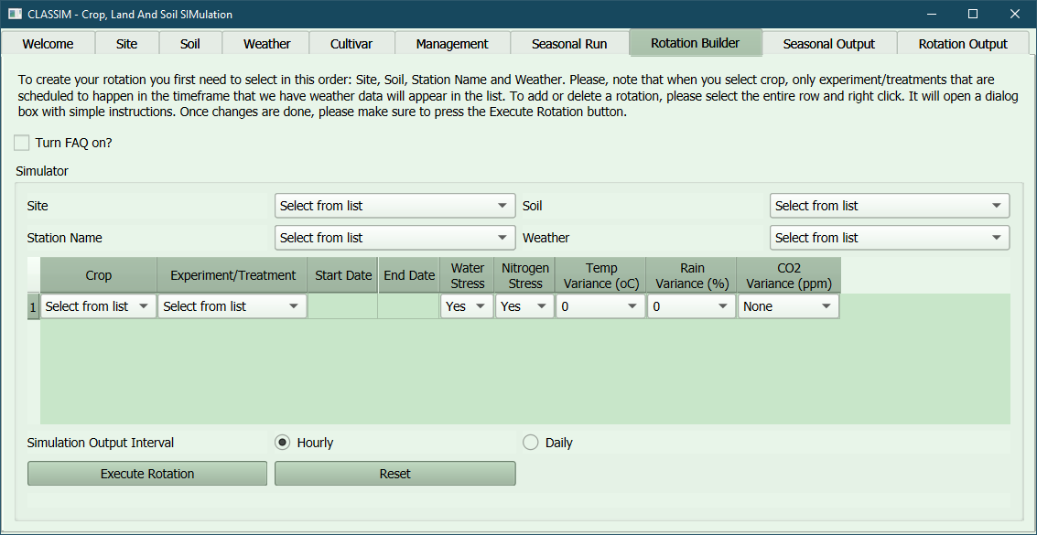

Figure 17: Rotation Builder example.

Currently there are options to study non-limited water and nitrogen conditions (potential yield) in the simulation run, but these only work for potato. User can also apply climate variance that will be applied for the temporal range of the simulation on temperature, rain, and CO2 for each rotation.

On Fig. 18, the BEOU site was selected, along with associated Soil, Station, and Weather data. The combination of maize/fallow/maize crops were selected for this rotation. NOTE: selection of an experiment/treatment combination for which the start/stop dates are outside the weather data range will cause an error during model execution!

When ready, the user can click on the ‘Execute Rotation’ button and select the desired data output interval. Daily output is considerably faster. The simulation progress will be displayed below the run button, when the rotation is completed, you will see the message ‘Check your simulation results on Output tab’, please allow up to 4 minutes for hourly output, less than 1 minute for daily. The output is now ready to look at Rotation Output tab.

Figure 18: Rotation Builder example for BEOU with rotation combination of maize/fallow/maize.

# ‘SEASONAL OUTPUT’ Tab

Simulation results from different seasonal runs can be displayed in this tab. Data can generally be viewed as 2D plots for above and below ground processes versus time as well as 2D spatial plots of different soil and root properties.

In Fig. 19, the seasonal run for BEOU was selected. To check all seasonal runs available for display use the sidebar on the right side of the table. To view simulation results, click on the ‘SimID’ column of your choice and then ‘Select Simulation’. The ‘Select Simulation’ bar will be grayed out while the data is being pulled from the database. You can also select a seasonal simulation for deletion, this action will delete local files created in your computer and delete the related information on the database.

After a few seconds after clicking on ‘Select Simulation’, ‘Simulation Summary’ subtab automatically appears on the window followed by other 6 subtabs where the information was organized by Plant, Soil Time Series, 2D Soil Water Heat Nitrogen, 2D Root, Surface Characteristics and Soil Carbon Storage.

Simulation Summary subtab includes end-of-season information including dates of different developmental stages, yield and dry mass data, and water and nitrogen use. A Table indicating days (or hours) in which stress occurred is shown. Values should range from 0 to 1, with 0 meaning no stress and ‘1’ meaning full stress.

Figure 19: Seasonal Output example displaying Simulation Summary for site BEOU planting corn in 2014.

The following sub-Tabs provide options to select various plots.

Plant

From here, over 20 variables can be selected for comparison versus calendar date. Dry mass for maize is shown below – there is an option to save the output as well (Fig. 20).

Figure 20: Plant subtab is being displayed for a maize simulation.

Soil Time Series

This tab displays six time series graphics for total water for entire profile, total water by layer, water content by layer, total NNO3 as nitrogen for the entire profile, total NNO3 as nitrogen by layer, and temperature by layer (Fig. 21).

Figure 21: Soil Time series subtab is being displayed for a maize simulation.

2D Soil Water Heat Nitrogen

CLASSIM will plot 2D x-y graphs for soil matric potential, soil water content, nitrogen concentration, and temperature based on user selected date (Fig. 22).

Figure 18: Soil Water Heat Nitrogen sub-Tab was selected on Seasonal Output tab.

2D Root

CLASSIM will plot 2D x-y graphs for root density total and root mass total based on user selected date (Fig. 23).

Figure 23:2D Root subtab.

Surface Characteristics

Variables related to evaporation, transpiration, rainfall, runoff, and other responses can be selected for comparison versus time series. The example below shows seasonal potential soil evaporation and seasonal actual soil evaporation (Fig. 24).

Figure 24: Surface Characteristics subtab.

Soil Carbon Storage

User can select variables related to amount of nitrogen and cardon for humus, litter, manure and root for comparison versus time series. The example below shows amount of nitrogen and carbon in root (Fig. 25).

Figure 25: Soil Carbon Storage subtab.

# ‘ROTATION OUTPUT’ Tab

Rotation output results from different rotations can be displayed in this tab. Data can generally be viewed as 2D plots for above and below ground processes versus time as well as 2D spatial plots of different soil and root properties.

In Fig. 26, the rotation for MD_Rhodesdale was selected, this rotation comprises of 3 simulations done in sequence (potato/fallow/potato). To check all rotations available for display use the sidebar on the right side bar of the table. To view rotation result, click on the ‘RotID’ column of your choice and then ‘Select Rotation’. The ‘Select Rotation’ bar will be grayed out while the data is being pulled from the database, please note that will take longer for this tab to load since the data for each simulation within rotation is being compiled together. You can also select a rotation for deletion, this action will delete local files created in your computer and delete the related information on the database.

After a few seconds after clicking on ‘Select Simulation’, ‘Rotation Summary’ subtab automatically appears on the window followed by other 6 subtabs where the information was organized by Plant, Soil Time Series, 2D Soil Water Heat Nitrogen, 2D Root, Surface Characteristics and Soil Carbon Storage.

Rotation Summary subtab includes end-of-season information including dates of different developmental stages, yield and dry mass data, and water and nitrogen use for each simulation.

Figure 26: Seasonal Output example displaying Simulation Summary for site BEOU planting corn in 2014.

The following sub-Tabs provide options to select various plots.

Plant

From here, over 20 variables can be selected for comparison versus calendar date. Dry mass for potato is shown below, since the rotation is comprised of potato/fallow/potato, the graphic doesn’t display plant information for the fallow period – there is an option to save the output as well (Fig. 27).

Figure 27: Plant subtab is being displayed for a potato/fallow/potato rotation.

Soil Time Series

This tab displays six time series graphics for total water for entire profile, total water by layer, water content by layer, total NNO3 as nitrogen for the entire profile, total NNO3 as nitrogen by layer, and temperature by layer for the whole rotation period (Fig. 28).

Figure 28: Soil Time series subtab is being displayed for potato/fallow/potato rotation.

2D Soil Water Heat Nitrogen

CLASSIM will plot 2D x-y graphs for soil matric potential, soil water content, nitrogen concentration, and temperature based on user selected date (Fig. 29).

Figure 29: Soil Water Heat Nitrogen sub-Tab was selected on Rotation Output tab.

2D Root

CLASSIM will plot 2D x-y graphs for root density total and root mass total based on user selected date (Fig. 30).

Figure 30: 2D Root subtab for Rotation Output.

Surface Characteristics

Variables related to evaporation, transpiration, rainfall, runoff, and other responses can be selected for comparison versus time series. The example below shows seasonal potential soil evaporation and seasonal actual soil evaporation (Fig. 31).

Figure 31: Surface Characteristics subtab.

Soil Carbon Storage

User can select variables related to amount of nitrogen and cardon for humus, litter, manure and root for comparison versus time series. The example below shows amount of nitrogen and carbon in root (Fig. 32).

Figure 32: Soil Carbon Storage subtab.

# SAMPLE – Input Data

CLASSIM installation will come with several sets of example input data for the various models. These are located in the Examples sub-folder. Users are encouraged to work their way through the examples of inputting the data, and perhaps more importantly, gaining confidence in varying the input data and observing the changes in the outputs. Example input locations include:

1) Carlow, Ireland

Potato study conducted in open-top chambers under ambient CO2 conditions. Study utilized unusually high planting densities. Users may want to explore varying CO2 concentration with the weather data.

2) Chapman, Maine

Potato study to evaluate cultivar response to different N amounts. Single N treatment provided. Users may want to explore fertilizer amounts.

3) Rhodesdale, Maryland

Two variety study in Maryland’s eastern shore for 2011 and 2012.

4) Jyndevad, Denmark

Potato yields under automatic irrigation under ambient conditions. User may want to explore increasing CO2 concentration.

5) CROWN and AgMIPET2

These are studies for corn modeling.

# APPENDIX A – Weather Data

Weather data can be in either hourly or daily time-steps. For daily values, minimum information includes solar radiation, maximum daily temperature, minimum daily temperature, and relative humidity. Values for rainfall and CO2 are optional and, if not provided in the datafile, will be pulled from the Station information associated with the weather file. An example of a daily weather file is shown below for several days. This is in *.csv format but is open in Excel to make it easier to read. Note the only header is for column names – additional information may throw an error in CLASSIM. This file includes values for solar radiation, maximum and minimum air temperature, rainfall, windspeed, and relative humidity:



Below is an example of hourly data. Similar information except there is an additional column for hour of day (0 to 23, with 0 representing the first hour after midnight). There are Example files in CLASSIM that the User should look at to gain familiarity for these requirements.



# APPENDIX B – Cultivar Variables and Units per Crop

Cultivar parameters used for cotton.

There are 60 parameters in the GOSSYM model, out of which only 35 parameters are varied while the rest are generally kept constant. In CLASSIM, the user has the capability to vary the 35 parameters, while the rest are not displayed in the interface. Below table shows which parameters in the GOSSYM model are kept constant and which ones are variable.

|  |  |
| --- | --- |
| **Description** | **Units** |
| Correction factor for root/shoot ratio |  |
| Factor for C-allocation to stem for days after emergence > variety parameter 13 |  |
| Maximum boll size | g |
| Minimum LAI that affects boll temperature |  |
| Minimum leaf water potential for the day in well-watered soil in the estimation of stem growth water stress | bar |
| Minimum leaf water potential in well-watered soil in the estimation of leaf growth water stress | bar |
| Number of days after emergence that controls C-allocation in to stem | day |
| Parameter in the estimation of mainstem leaf area at unfolding |  |
| Parameter in the estimation of bolls lost due to heat injury |  |
| Parameter in the estimation of current internode length |  |
| Parameter in the estimation of duration of leaf area expansion |  |
| Parameter in the estimation of fruiting branch leaf area at unfolding |  |
| Parameter in the estimation of initial internode length in plant height calculation |  |
| Parameter in the estimation of internode elongation duration in plant height calculation |  |
| Parameter in the estimation of leaf age |  |
| Parameter in the estimation of leaf growth water stress |  |
| Parameter in the estimation of morphogenetic delays due to N-stress |  |
| Parameter in the estimation of potential boll growth |  |
| Parameter in the estimation of potential daily change in mainstem and pre fruiting leaf weight |  |
| Parameter in the estimation of potential daily change in mainstem leaf area |  |
| Parameter in the estimation of potential daily change in pre-fruiting leaf area |  |
| Parameter in the estimation of potential square growth |  |
| Parameter in the estimation of pre-fruiting leaf area at unfolding |  |
| Parameter in the estimation of reduction to initial internode length when the number of main stem nodes < 14 |  |
| Parameter in the estimation of reduction to initial internode length when the number of main stem nodes>=14 |  |
| Parameter in the estimation of the physiological days for leaf abscission |  |
| Parameter in the estimation of time from emergence to first square |  |
| Parameter in the estimation of time from emergence to open boll |  |
| Parameter in the estimation of time from first square to bloom |  |
| Parameter in the estimation of time interval between nodes in the main stem and fruiting branch |  |
| Parameter in the estimation of time interval between nodes in the vegetative branches |  |
| Parameter in the estimation time interval between pre-fruiting node |  |
| Relates boll safe age from abscission with age for the boll, C and N-stress |  |
| Relates potential fruit growth with temperature stress |  |
| Relates potential fruit growth with water and temperature stress |  |

Cultivar parameters used for maize.

|  |  |
| --- | --- |
| **Description** | **Units** |
| Daylength Sensitivity |  |
| JuvenileLeaves |  |
| PhyllFrmTassel (Phyllochrons from tassel) |  |
| Rmax_LTAR (Leaf Tip Appearance Rate) |  |
| Rmax_LTIR (Leaf Tip Initiation Rate) |  |
| StayGreen (Relative varietel parameters that control onset of senescence) |  |

Cultivar parameters used for potato.

|  |  |
| --- | --- |
| **Description** | **Units** |
| Daily Air Temperature Amplitude Effect |  |
| Daily Air Temperature Effect |  |
| Determinacy |  |
| High Nitrogen Effect |  |
| Low Nitrogen Effect |  |
| Maximum Canopy Leaf Expansion Rate |  |
| Maximum Tuber Growth Rate |  |
| Photoperiod Effect |  |
| Specific Leaf Weight |  |

Cultivar parameters used for soybean.

|  |  |
| --- | --- |
| **Description** | **Units** |
| Coefficient ‘a’ in relationship between height and V stages | - |
| Coefficient ‘b’ in relationship between height and V stages | - |
| Correction factor for the early V rate to account for clay content | - |
| Daily rate of the progress to floral initiation after solstice | day-1 |
| Daily rate of the progress to floral initiation before solstice | day-1 |
| Intercept of the dependence of full bloom end on the Julian Day First |  |
| Length of the plateau first seed | day-1 |
| Length of the plateau full seed with no stress | day-1 |
| Maturity Group |  |
| Maximum of Vegetative stage | - |
| Number of seeds per pound weight typical for cultivar | Number lb-1 |
| Potential rate of the root weight increase | - |
| Progress rate from floral initiation towards full bloom | day-1 |
| Progress rate from full bloom towards full seed | gdd |
| Progress rate towards floral initiation at solstice | day-1 |
| R stage to stop vegetative growth | - |
| Rate of the decay of the R6 plateau as the stress increases | day-1 |
| Rate of the progress towards physiological maturity | gdd |
| Relates increase in pod weight and progress in R stages | - |
| Relates increase in seed weight and FILL | - |
| Relates increment in leaf area to increment in vegetative stages | - |
| Relates number of branches with the plant density | - |
| Relates potential elongation and dry weight increase petioles | - |
| Relates stem weight to stem elongation | - |
| Seed fill rate at 24oC | mg seed-1 day-1 |
| Slope of the dependence of full bloom end on the Julian Day First | day-1 |
| Slope of the dependence of VSTAGE on temperature integral | gdd |

# APPENDIX C – Output Variables and Units

**A**

Actual Soil Evaporation, mm cm-2

Actual Transpiration, g plant-1 (corn)

mg plant-1 (potato, soybean)

Air Temperature at 2 m, oC

Available Water in Root Zone, g

Average Stomatal Conductance, umol H2O m-2 s-1

**C**

Canopy Temperature, oC

Carbon Allocated to Roots, g plant-1

**D**

Dead Dry Matter, g plant-1

Dropped Leaf Dry Matter, g plant-1

**E**

Ear Dry Matter, g plant-1

**F**

Dead Leaf Area, cm2

**G**

Green Leaf Area per Plant, cm2

Gross Photosynthesis, mg CO2 m-2 h-2

**L**

Leaf Area, cm2

Leaf Area Index, m2 leaf m ground

Leaf Dry Matter, g plant-1

Leaf Nitrogen, mg plant-1 (potato)

Leaf Nitrogen Content, %

Leaf Water Potential, bars

**M**

Maximum Root Depth, cm

Maximum Stomatal Conductance, umol H2O m-2 s-1

**N**

Net Photosynthesis, g CO2 plant-1 day-1

Nitrogen Demand, g plant-1

Nitrogen Uptake, g plant-1 (corn)

mg plant-1 (potato)

Number of Dropped Leaves, number of leaves

Number of Leaves (Appeared), number of leaves

Number of Mature Leaves, number of leaves

**P**

Photosynthetic Flux Density, mol photons m-2day-1

Pod Dry Matter, g plant-1

Potential Soil Evaporation, mm cm-2

Potential Transpiration, g plant-1 (corn)

mg plant-1 (soybean, potato)

Potential Transpiration by Leaf Energy Balance, mm cm-2

**R**

Relative Humidity, %

Respiration, mg CO2 m-2 h-2 (corn)

µmol m-2 s-1 (potato)

Root Dry Matter, g plant-1

Root Nitrogen, mg plant-1

Runoff, mm cm-2

**S**

Seasonal Actual Soil Evaporation, mm cm-2

Seasonal Actual Transpiration, mm cm-2

Seasonal Infiltration, mm cm-2

Seasonal Potential Soil Evaporation, mm cm-2

Seasonal Potential Transpiration, mm cm-2

Seasonal Rainfall, mm cm-2

Seed Dry Matter, g plant-1

Shoot Dry Matter, g plant-1

Soil Temperature at Soil Surface, oC

Solar Radiation, W m-2

Soluble Sugars as Carbon, g plant-1

Soil Root Dry Matter, g plant-1

Stage, number of leave

Stem Dry Matter, g plant-1

Stem nitrogen, mg plant-1

**T**

Total Dry Matter, g plant-1

Tuber Dry Matter, g plant-1

Total Nitrogen in the Plant, mg plant-1

Transpiration, mm cm-2

Tuber Nitrogen, mg plant-1

**V**

Vapor Pressure Density, kPa

# APPENDIX D – Technical Odds and Ends

The crop models integrated with CLASSIM provide options to simulate output at hourly or daily time-steps. Daily time-steps require considerably less execution time (4 to 5 fold difference). Typical execution time for daily output should be less than 45 seconds depending on soil and climate properties in the user rotation. So, we suggest the user only select the Daily output option in the Rotation Builder Tab unless hourly data is important, in which case model runs can take between 2 to 5 minutes.

# APPENDIX E – CLASSIM Data File Storage

Model input files are stored in individual ‘run’ folders that are subfolders in the ‘Crop_Int’ directory. To keep hard drive storage down, all output files are ingested into an SQL database upon successful completion of a model run. This database is then used by CLASSIM to pull out all information requested in the Output tab. Future efforts will include more direct user access of the database to conduct queries, sensitivity analyses, and other functionalities that traditional flat files do not provide.

The database itself can be opened with a 3rd party software, such as DB Browser, if desired, but changes can cause problems with your stored runs, so be warned. The database can use a standard ODBC connector to connect to any program – R, SAS, Python, Excel, etc, mysql. There are two databases, “crop.db” and “cropoutput.db”. The former database stores all FAQs and input date. The latter contains the results of all model runs, either hourly or daily.

Users interested in obtaining the original flat file outputs, can re-run the model from the command line using these input files that were stored. Information on how to run the model from command line is provided in a companion model manual (partially complete at this time).

# APPENDIX F – KNOWN MODEL BUGS

Sandy soils: For especially sandy soils (e.g. 94% or more sand content), numerical convergence issues can occur due to lack of moisture holding capacity. The model execution can crash in these instances. This situation is more likely to occur for potato than in other crops and was noted, for example, at locations in Prosser, Washington (US). Possible fixes can be to increase initial water content (e.g. use values higher than -200cm per layer) in the soil profile or manual decrease the sand content a few percentages. A more realistic option is also to increase irrigation – potatoes grown in sandy soils are typically irrigated, adding the automatic irrigation eliminates this problem. We are currently looking for work-around options.

Start time / Planting dates: Simulation time in the model should be at least 3 or more days before sowing/planting date. This is required to initialize the soil profile. Model may run still run but error can occur. CLASSIM has a check for this situation but user should be aware of this need.

# USER EXPERIENCE

Please provide feedback here, positive or negative, for us to improve the Interface, or contact [Dennis.Timlin@usda.gov](mailto:Dennis.Timlin@usda.gov)

***

Screen resolution issues

-when CLASSIM initially opens, the interface is small, resolution of text hard to read

Rotation Builder

-Here and other Tabs, at times new entries aren’t updating in CLASSIM lists automatically. A work-around was to add a row, then delete prior row, but there needs to be more user-friendly way.

Nebraska Interests

-N movement to deeper (much deeper 100+feet profile) – influence of N addition / Heavy rain on movement through and out of profile